Power BI OLAP Operations – Assignment 1
1. Roll-up
The roll-up operation is demonstrated using the Matrix visual. The data is organized using the hierarchy Year → Quarter → Month. When the hierarchy is collapsed from Month and Quarter to Year, the data is summarized at a higher level. This demonstrates roll-up.
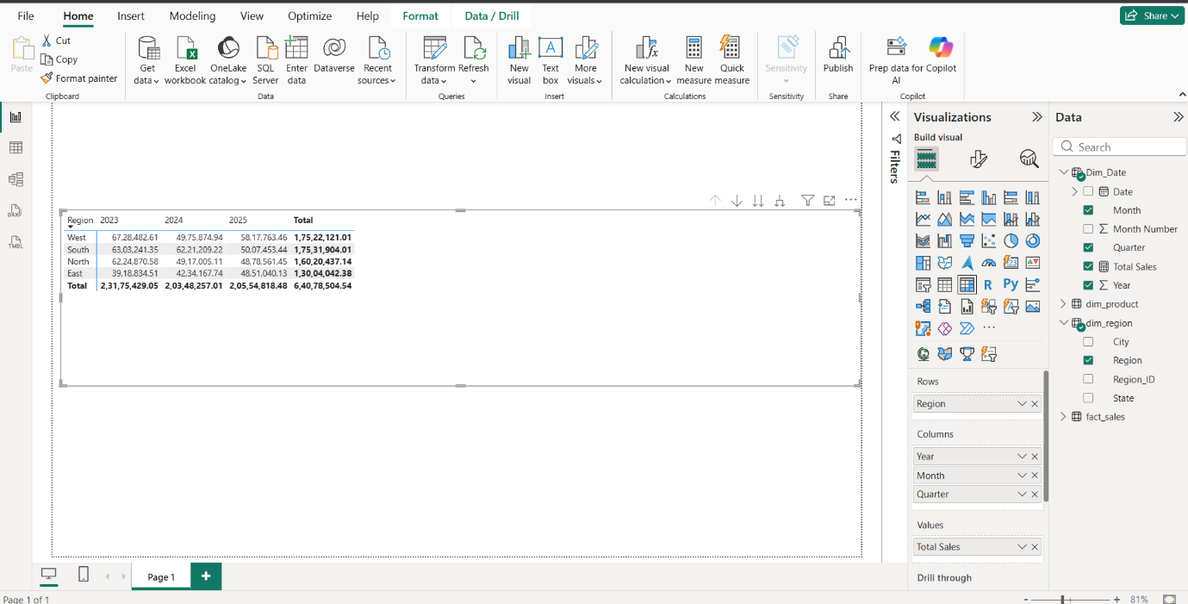
2. Drill-down
The drill-down operation is demonstrated by expanding the Year level into Quarter and then Month. This allows the user to move from summarized yearly sales to more detailed quarterly and monthly sales information.
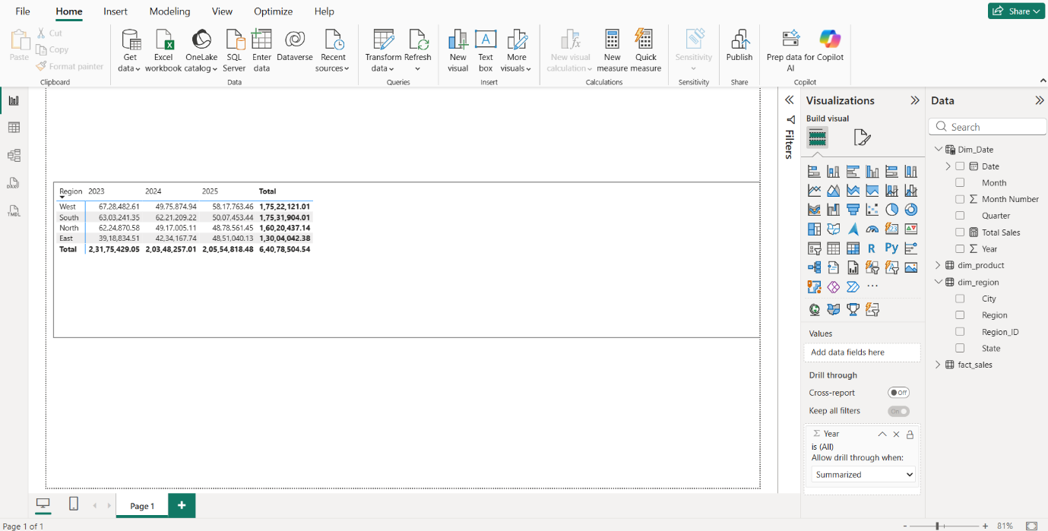

3. Slice
The Category slicer demonstrates slicing. By selecting a single category, such as Technology, the report displays sales information only for that selected category.
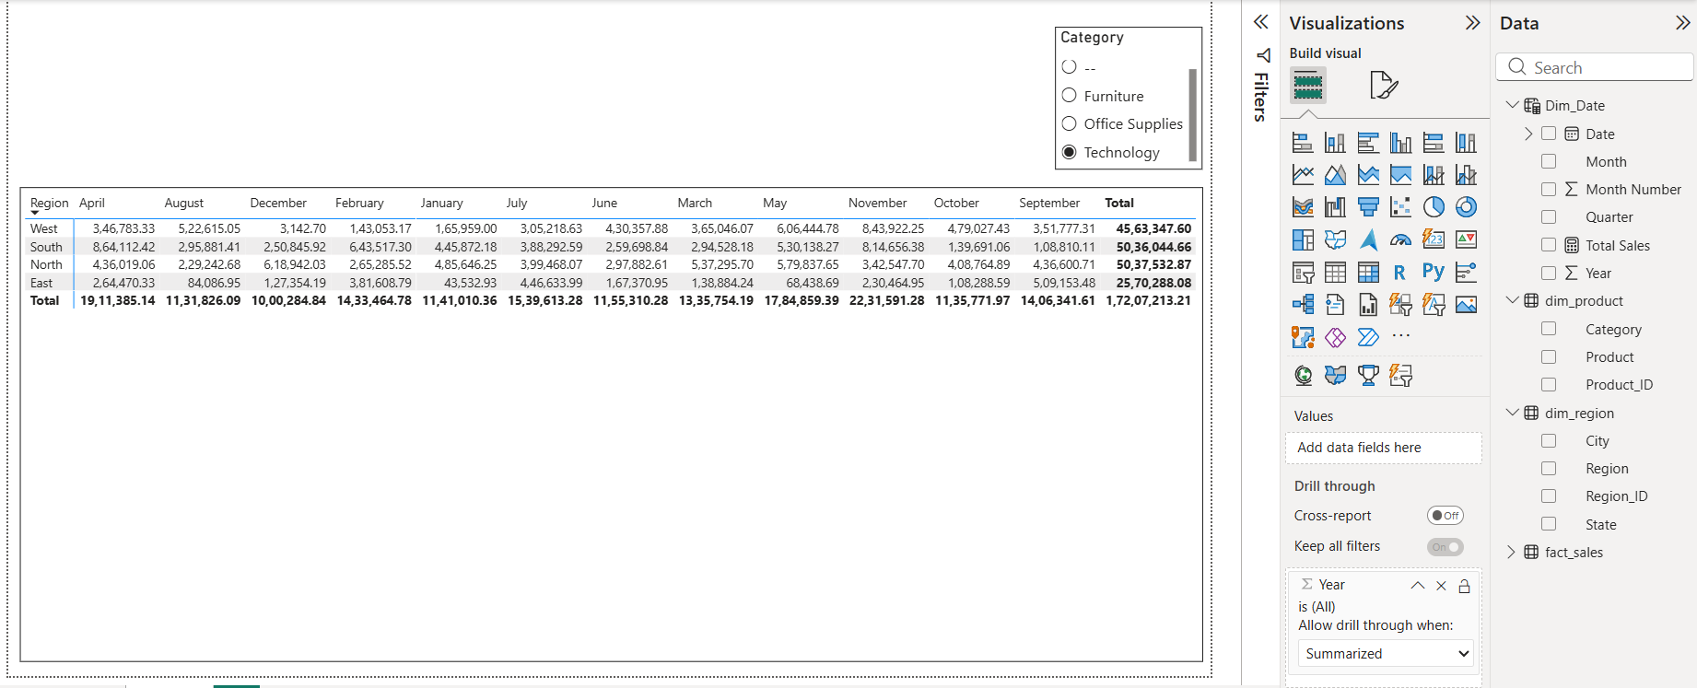
4. Dice
The combination of the Category and Region slicers demonstrates dicing. For example, selecting Technology and South filters the data using two dimensions simultaneously.
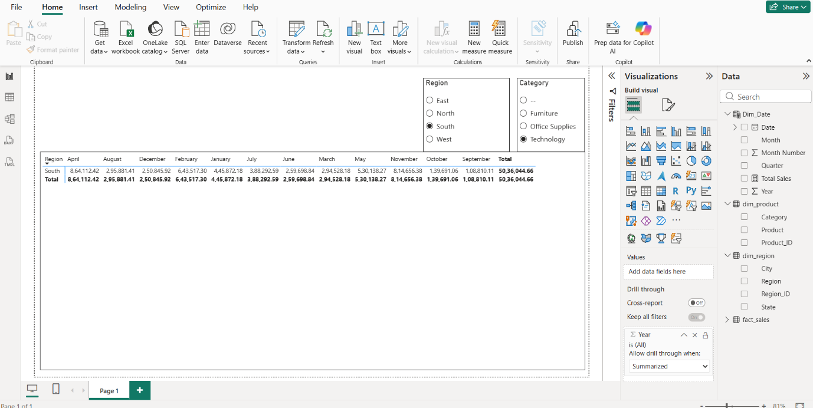

5. RANKX Analytic Measure
The Product Rank DAX measure uses RANKX() to rank products according to their total sales. This helps identify the highest- and lowest-performing products.
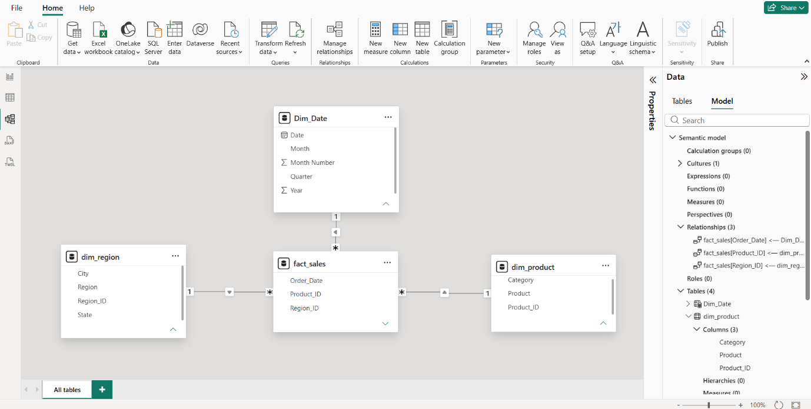
6. Time-Intelligence Measure
The Previous Month Sales and MoM Growth measures compare the current period with the previous month. This helps identify whether sales are increasing or decreasing over time.
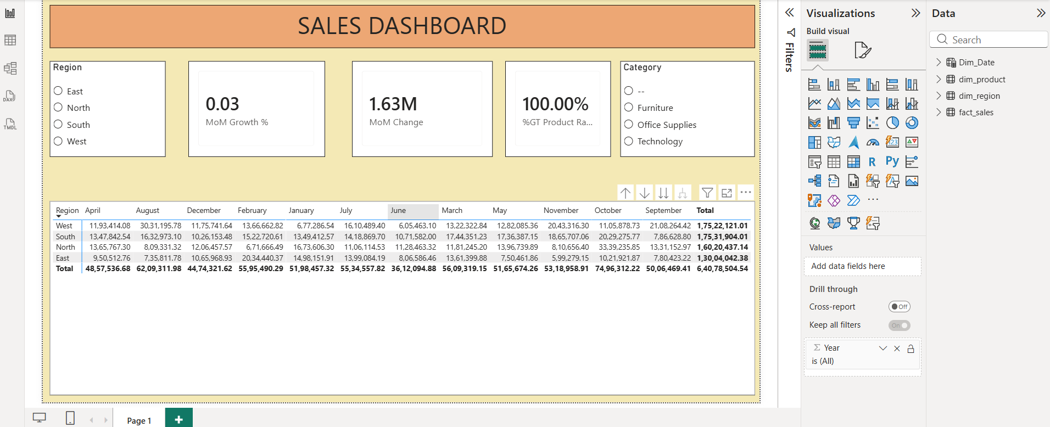
Conclusion
The Power BI dashboard demonstrates how a star-schema data model and OLAP operations can support business analysis. Roll-up and drill-down provide different levels of detail, while slice and dice allow users to analyze selected portions of the data. The DAX measures provide additional analytical insights for ranking and period-over-period comparison.

